/\*Ashok IPBC - Mortgage Project Intro Lab 7.21.19\*/

Video(s) to Submit:

1. IPBC Status Update : Mortgage Project Intro –

Now that you have a better understanding of the Mortgage Project, you will submit a video explaining the project.

Scenario: You are the most senior person on the team. The Director of BI has just hired a team consisting of a Project Manager, BA, Developers and testers. They are new to the company and know nothing about the project so you must explain to your counter parts what the project entails. Provide a detailed introduction of Mortgage project client, requirements and deliverables. How would you apply SDLC / Agile methodology to implement this project?

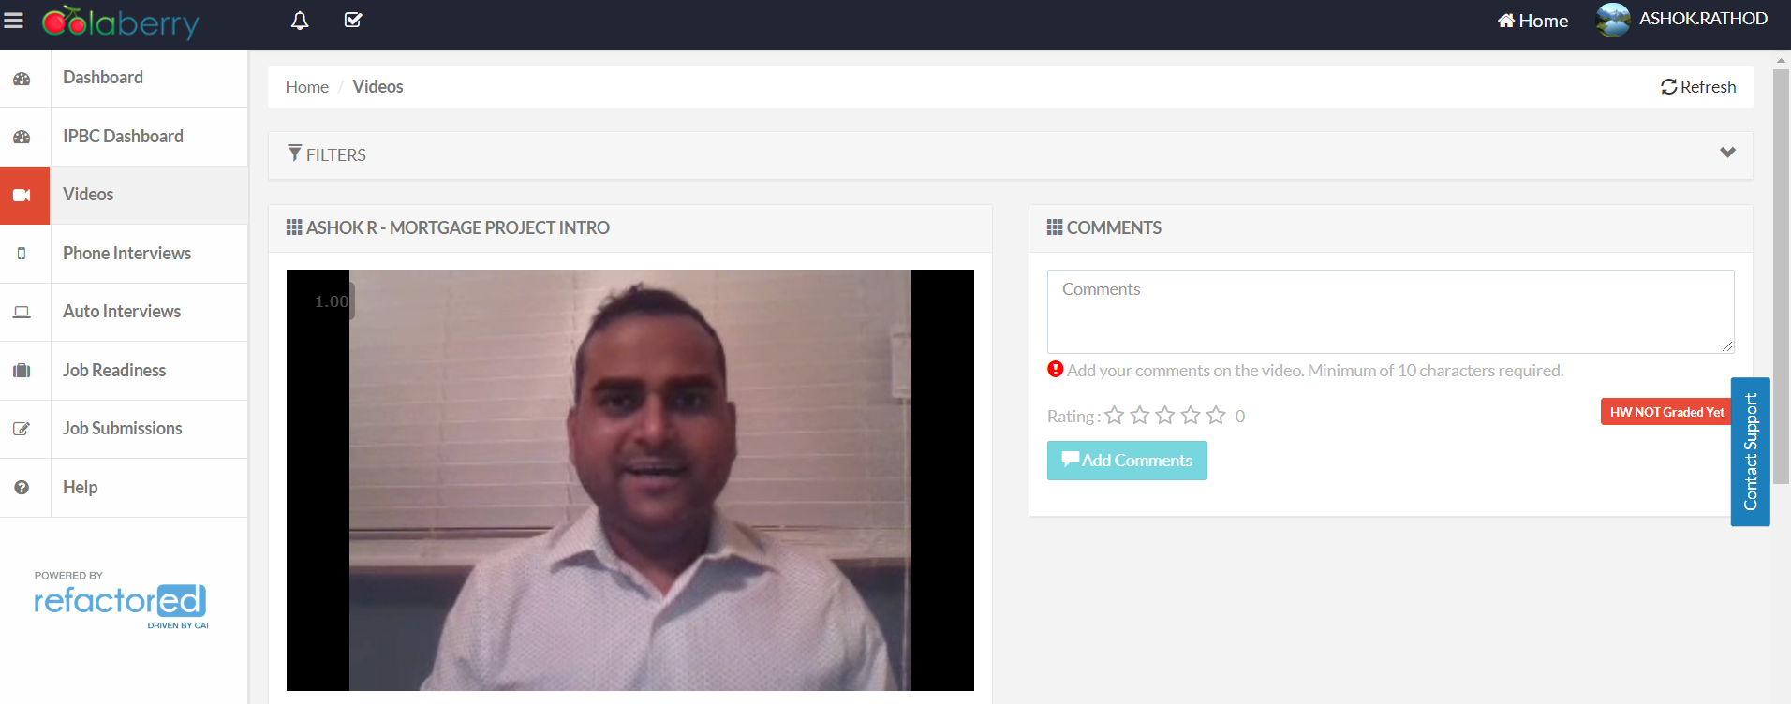

2. SQL BI Interview Questions: SQL – What is the difference between UNION and UNION ALL

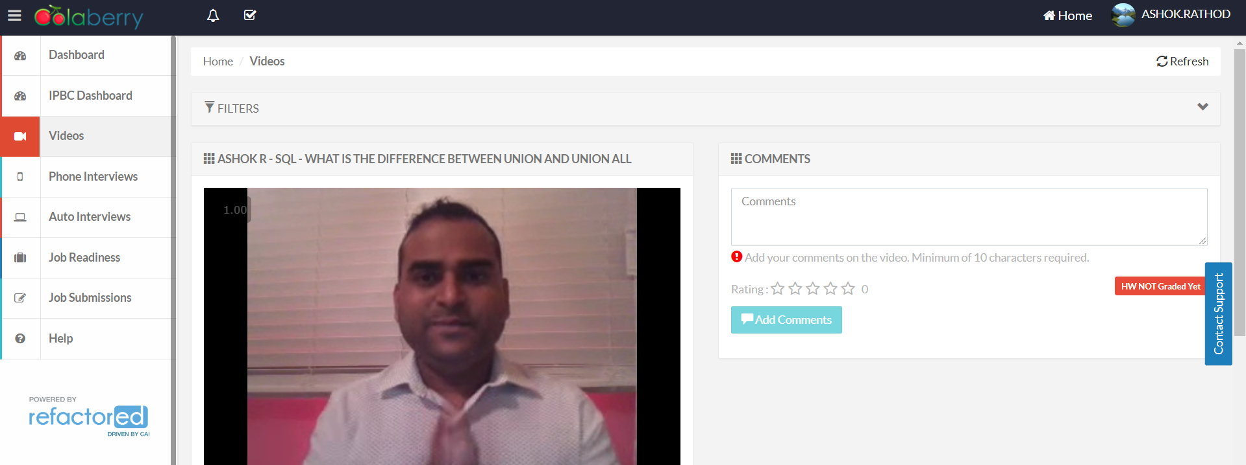

What to Submit:

1. Copy and paste the link to your video(s) as part of your homework.

* <https://app.colaberry.com/app/ipbc/videos?user=31221&category=9>
* <https://app.colaberry.com/app/ipbc/videos?user=31221&category=28>

2. Watch, Comment &amp; take screenshots of your comments from 3 other videos on the same topic (per question). Comments must be 20+ characters. Leave comments based on presentation, delivery and/or technical details. Your critiques will help you be more conscious of your own videos. (3 comment screenshots per Video Question)

* Difference between Union and Union All

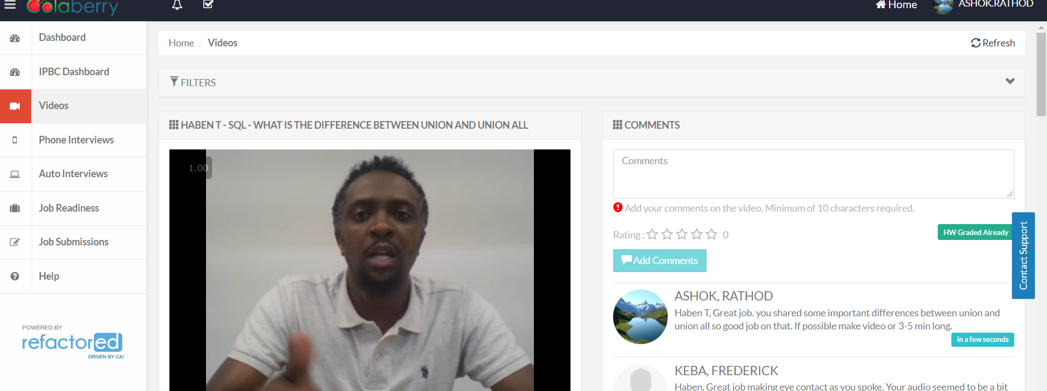

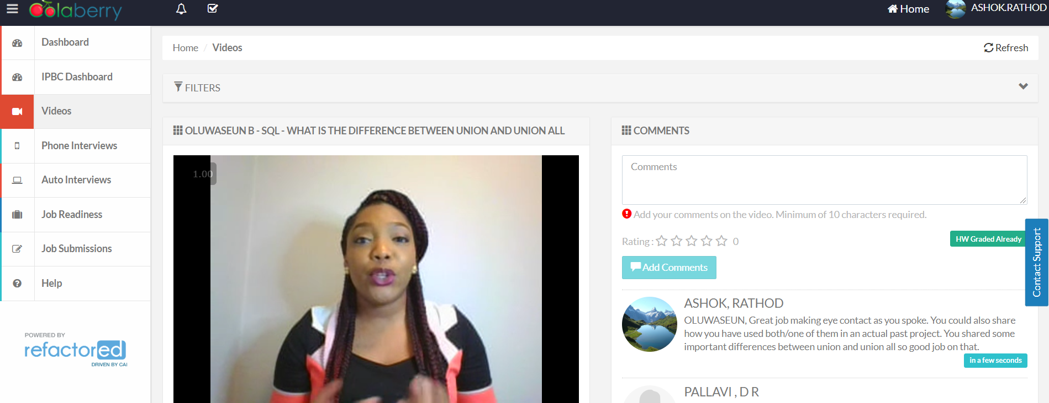

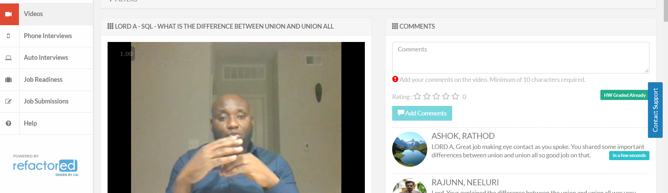

* IPBC Status Update : Mortgage Project Intro

